Jesse Martino

JavaFx Assignment

11/06/2017

**Vital Information:**

Java Programming BCS_345, Fall, 2017

Jesse_Martino

Week 10_JavaFx

Programming_Assignment_2

Due_Date_11_07_2017

**Problem Statement:** We were asked to alter an existing javaFx program in order to keep the menu for disappearing when changing scenes (specifically from HTML to CSS scenes). The code resembles a simple menu selection program in javaFX.

**Structure Chart:**

Main Menu

SQL Menu Choice

Web Menu Choice

CSS Scene

HTML Scene

**Structure Flow:**

Step 1 was to analyze the existing code in order to gain a further understanding of what the program is designed to accomplish.

Step 2 was to assemble the code in NetBeans and get it up and running.

Step 3 was to research possible methods on how to get the menu to stay when switching scenes.

Step 4 was to apply the correct method to the existing code.

Step 5 was to make sure the new code integrates well with the existing code with minimal errors.

Step 6 was to debug and run the program to test the steps completed in step 4 and 5.

**Implementation:**

Subprogram Name: Main Menu

Input: This program requires the user to select a menu item from the main menu located at the top left of the screen once the program is running.

Output: Once a selection is made, the output is to get to the desired scene the user has selected.

Algorithm: open application;

menu selection required;

select file -> (dropdown);

select Web -> (dropdown);

select SQL - > (dropdown);

exit application;

Subprogram Name: Web Menu Choice

Input: This program requires the user to select the Web menu choice from the main menu located at the top left of the screen once the program is running.

Output: Once a selection is made, the output is to get to the desired scene the user has selected. In this case, the program would go to one of two choices (HTML or CSS).

Algorithm: open application;

menu selection required;

select Web -> (dropdown);

in dropdown select HTML or CSS tab;

Subprogram Name: HTML Scene

Input: This program requires the user to select the HTML tab from the Web menu choice located at the top left of the screen once the program is running.

Output: Once a selection is made, the output is to get to the desired scene the user has selected. In this case, the program would go to the HTML scene.

Algorithm: open application;

menu selection required;

select Web -> (dropdown);

in dropdown select HTML;

Scene change to scene1;

Subprogram Name: CSS Scene

Input: This program requires the user to select the CSS tab from the Web menu choice located at the top left of the screen once the program is running.

Output: Once a selection is made, the output is to get to the desired scene the user has selected. In this case, the program would go to the CSS scene.

Algorithm: open application;

menu selection required;

select Web -> (dropdown);

in dropdown select CSS;

Scene change to scene2;

Subprogram Name: SQL Menu Choice

Input: This program requires the user to select the SQL tab from the Main Menu located at the top left of the screen once the program is running.

Output: Once a selection is made, there is no output for the desired tab. This feature of the code is not applicable for the purpose of this assignment.

Algorithm: open application;

menu selection required;

select SQL -> (dropdown);

**Test Description and Results:**

This program does accurately solve the problem at hand. It does allow the user of the javaFx program to alter between sceen1 and sceen2 (specifically HTML and CSS scenes) while keeping the menu bar at the top. Proper debugging and testing was recorded in order to achieve this result. This program should not have any bugs mainly because there is no room for error on the user’s side. The user is simply navigating through a javaFx menu application program which makes the user choices to either select an option from the menu or exit the application.

**Epilogue:** Overall, I thought this assignment was challenging. I understood the structure of the code provided to me and I was able to get the existing code up and running. But obtaining the required information to complete the goal was definitely a challenge. I was not able to find the desired methods anywhere in the textbook or in the PowerPoint slides. This made achieving the goal of the assignment much more complicated that it should have been.

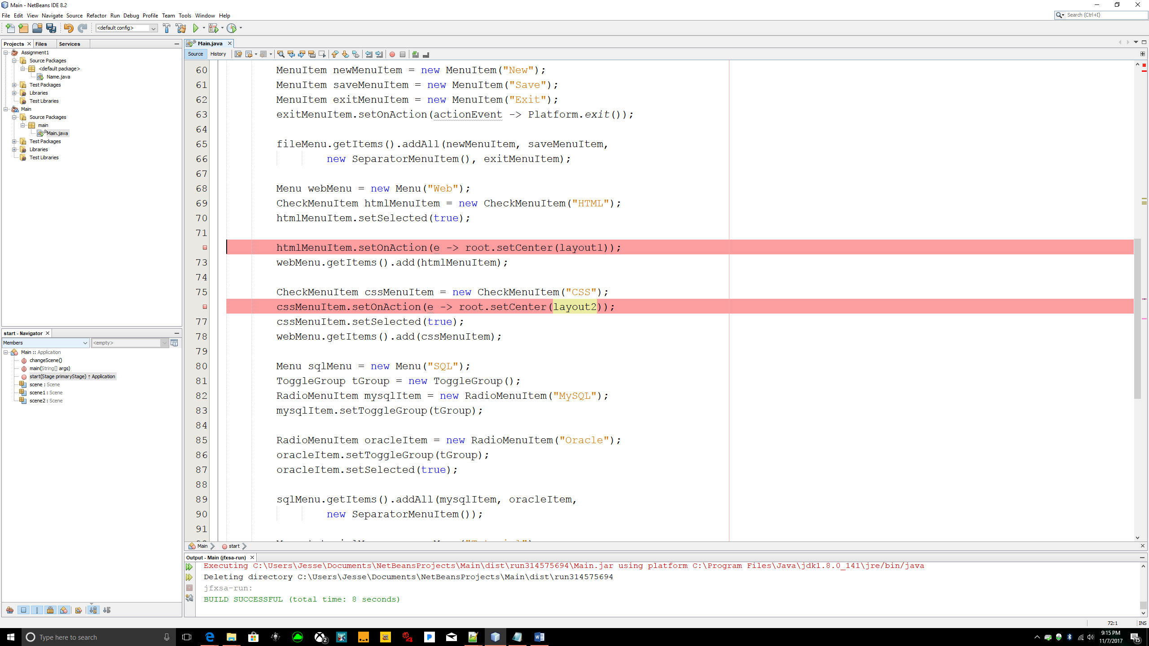Lines 72 and 76 are the major changes to this program which will allow the menu to stay at the top of the screen while switching between scene 1 and scene 2.

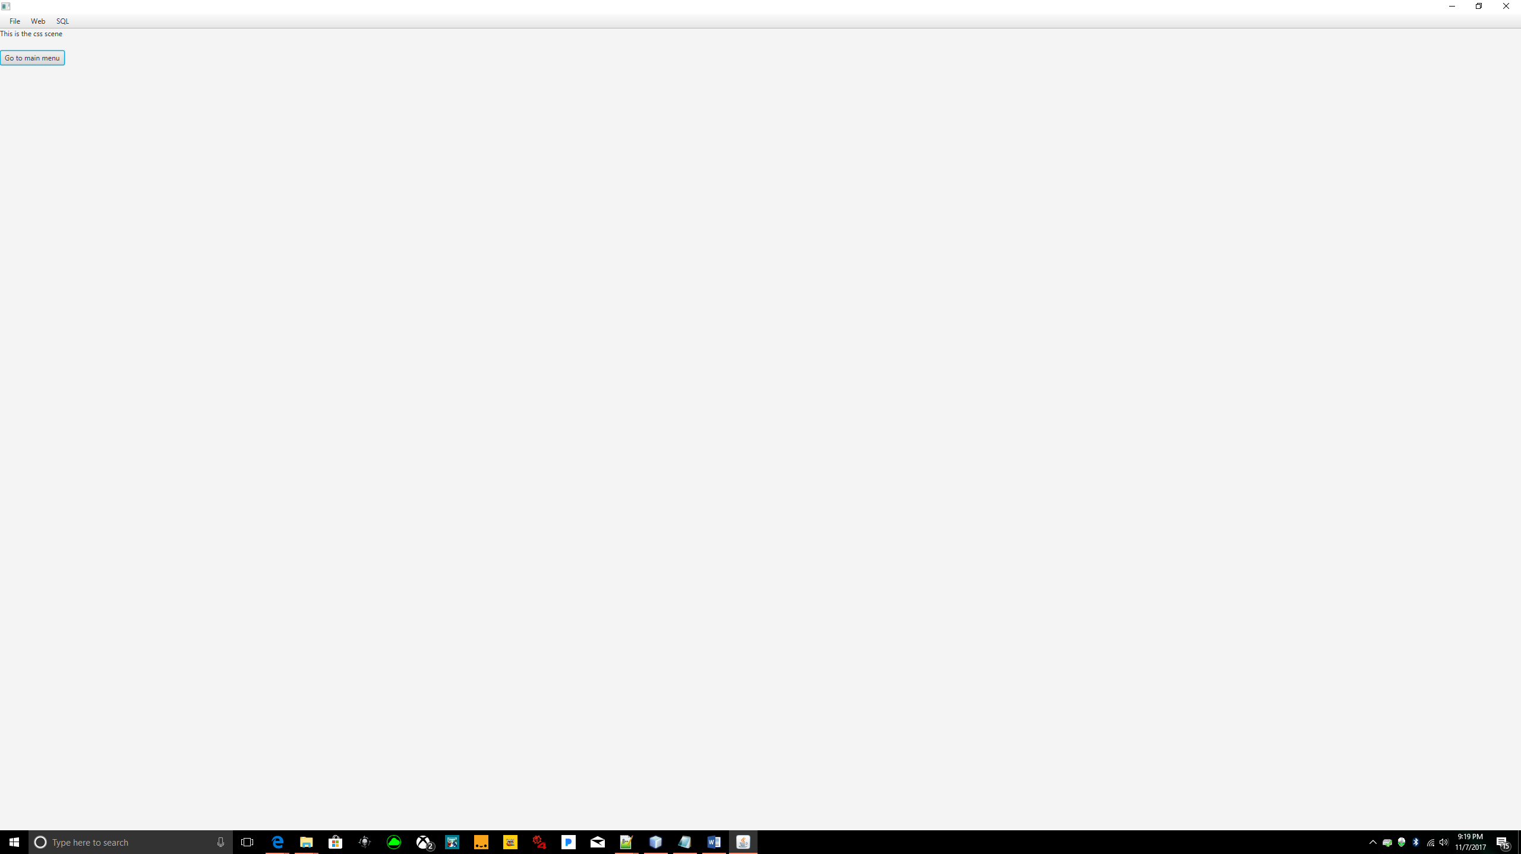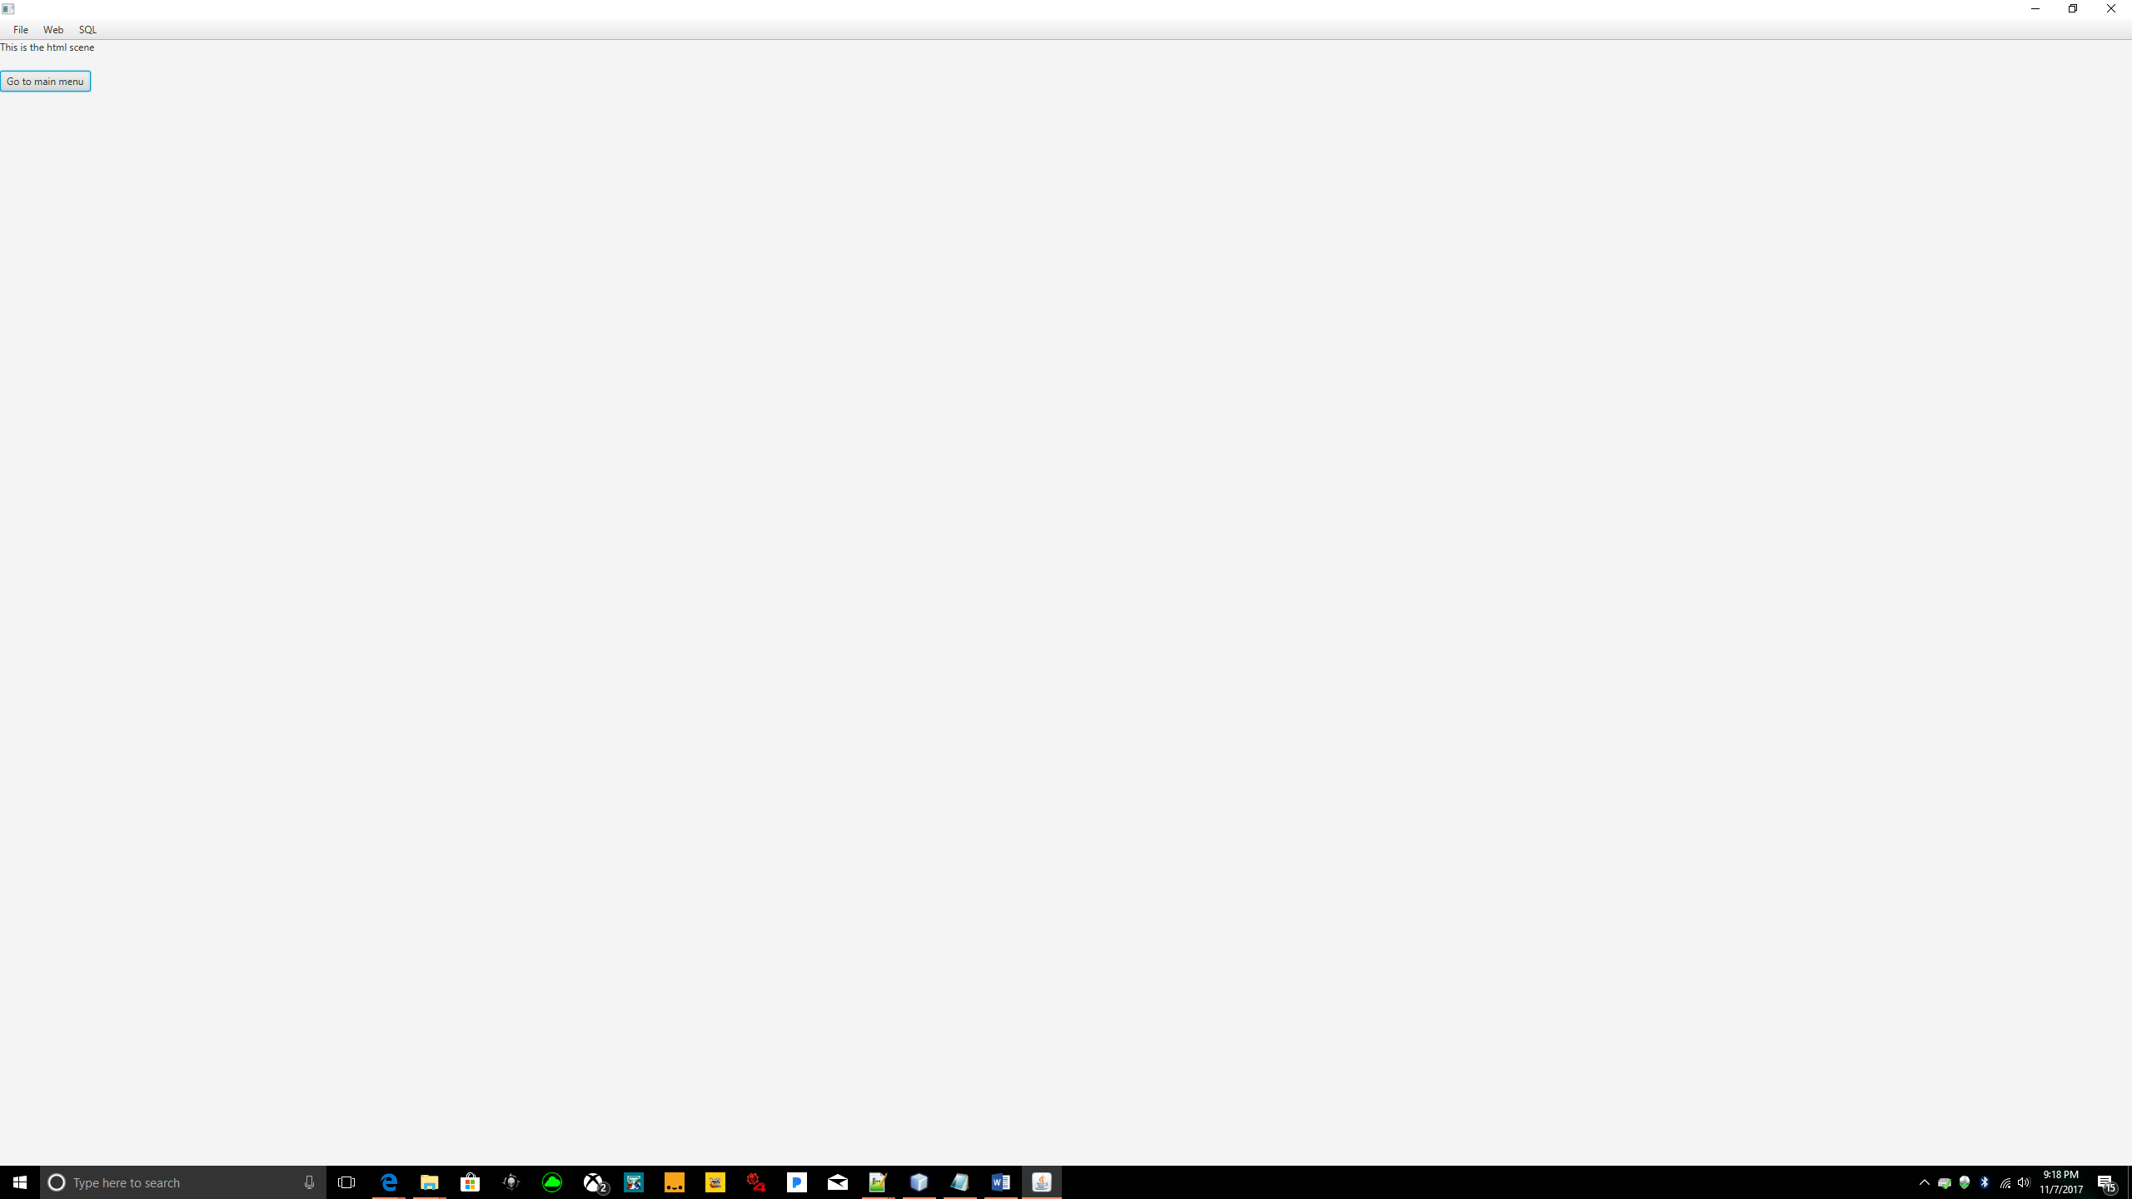

These figures represent how you are able to change from one scene to another while the menu stays located at the top left corner.